File permissions in Linux

Project description
Linux commands enable you to change the permissions of users, groups, and others in a directory. These reflect an organization’s levels of authorization and can help an organization follow the Principle of Least Principle to improve their security.

Check file and directory details
The Linux command used is ls -la.
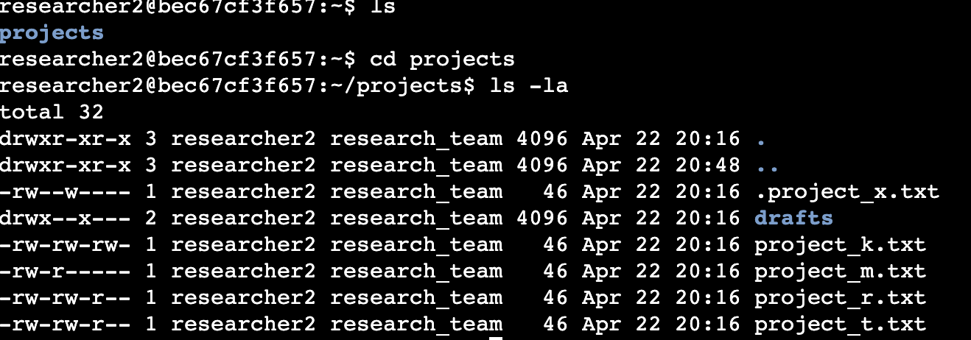

Describe the permissions string
One example of the permissions string is for the drafts directory. The permissions string is drwx--x---. The d indicates drafts is a directory, not a file. The next three symbols indicate the permissions for the user. They are read (since r is present), write (since w is present), and execute (since x is present). The next three symbols indicate the permissions for the group. Since only x is present, the group can only execute. The next three symbols indicate the permissions for other. Since there are all dashes, there are no read, write, or execute permissions for other.

Change file permissions
Since the organization does not allow others to have write access, write access is removed for others for project_k.txt using chmod o-w project_k.txt.
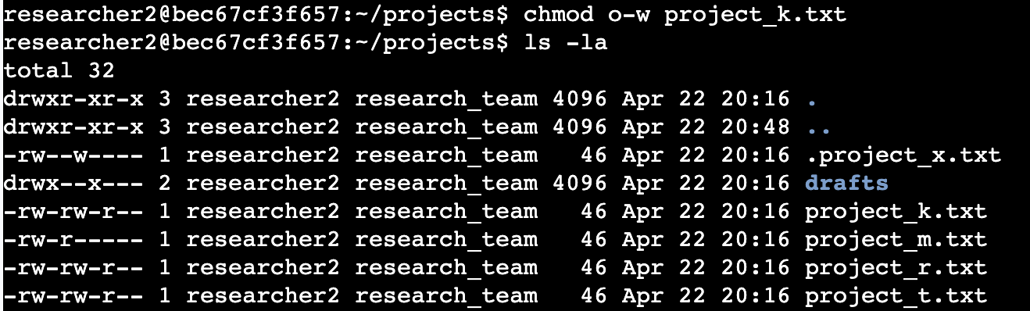

Change file permissions on a hidden file
The organization does allow write access for the user or group for the archived file .project_x.txt, but allows read access for both. The command chmod u-w,g-w,g+r .project_x.txt changes the current permissions to these.
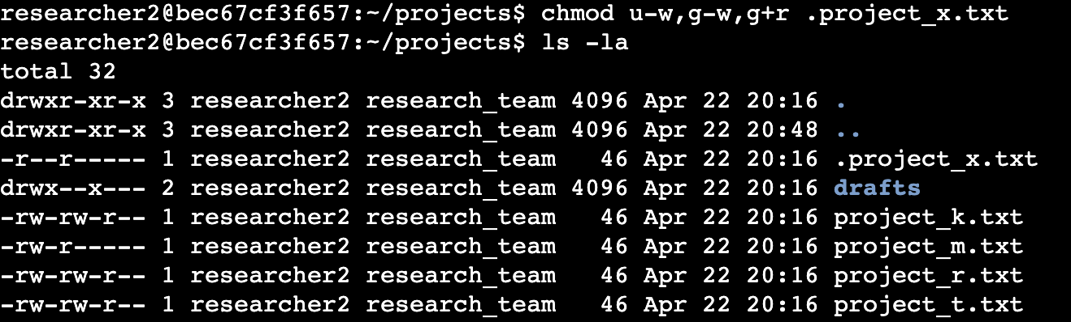

Change directory permissions
Since researcher2 should be the only person to access the drafts directory, the execute permissions for the group should be removed. This is done with the command chmod g-x drafts.
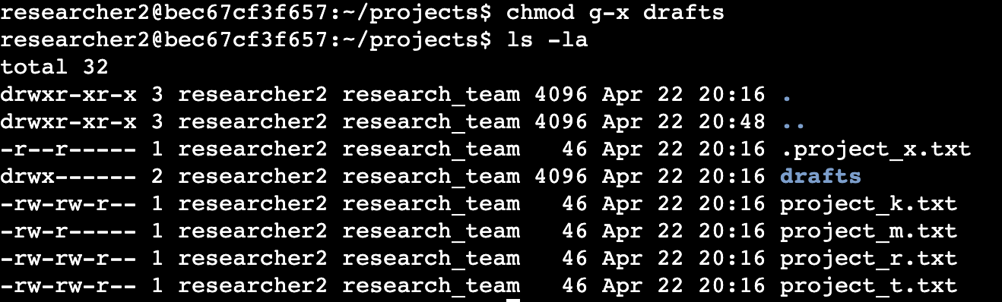

Summary
Multiple permissions were changed to match the authorization the organization desired for the user, group, and other. Commands such as ls -la were used to identify the current permissions of the drafts directory and files in the projects directory. Commands such as chmod were used to change the current permissions to the desired permissions of the organization.

